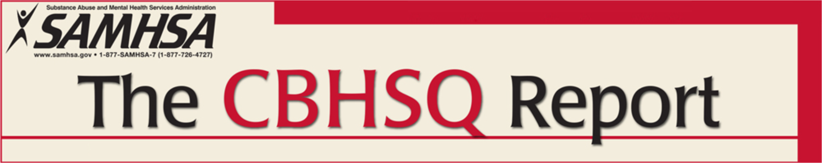
National Survey on Drug Use and Health
Short Report
April 16, 2015

Original reference to this article
http://www.drugtestlawadvisor.com/2015/04/28/federal-government-study-shows-persistent-substance-abuse-in-u-s-workforce/

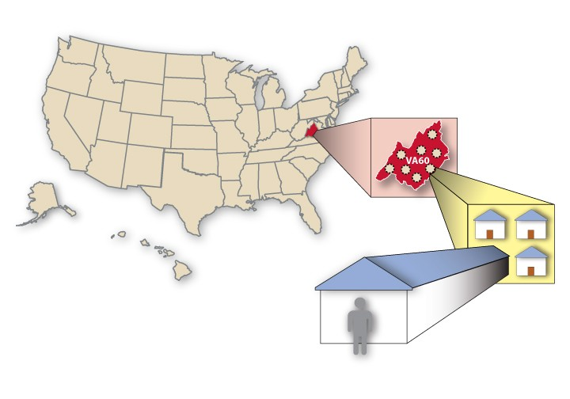
SUBSTANCE USE AND SUBSTANCE USE DISORDER BY INDUSTRY
In Brief
●
Combined data from 2008 to 2012 indicate that an
annual average of 8.7 percent of full-time workers aged 18 to 64 used alcohol heavily in the past month, 8.6 percent used illicit drugs in the past month, and 9.5 percent were dependent on or abused alcohol or illicit drugs in the past year.
●
The highest rates of past month heavy alcohol use
among full-time workers aged 18 to 64 were found in the mining (17.5 percent) and construction industries (16.5 percent).
●
The highest rates of past month illicit drug use
were found in the accommodations and food services industry (19.1 percent).
●
The workers in the accommodations and food
services industry (16.9 percent) had the highest rates of past year substance use disorder.

AUTHORS

Donna M. Bush, Ph.D., F-ABFT, and Rachel N. Lipari, Ph.D.

INTRODUCTION

Substance use negatively affects U.S. industry through lost productivity, workplace accidents and injuries, employee absenteeism, low morale, and increased illness. U.S. companies lose billions of dollars a year because of employees' alcohol and drug use and related problems.1 Research shows that the rate of substance use varies by occupation and industry.2

The National Survey on Drug Use and Health (NSDUH) gathers information about substance use and dependence or abuse. NSDUH defines illicit drugs as marijuana/hashish, cocaine (including crack), inhalants, hallucinogens, heroin, or prescription-type drugs used nonmedically.3 Heavy alcohol use is defined as drinking five or more drinks on the same occasion (i.e., at the same time or within a couple of hours of each other) on 5 or more days in the past 30 days. NSDUH also includes a series of questions to assess symptoms of dependence on or abuse of alcohol or illicit drugs during the past year. These questions are used to classify persons as dependent on or abusing substances based on criteria in the fourth edition of the Diagnostic and Statistical Manual of Mental Disorders (DSM-IV).4 In this report, dependence on or abuse of alcohol or illicit drugs is referred to as a "substance use disorder."

This report is one of several designed to update SAMHSA’s Analytic Series A–29, Worker Substance Use and Workplace Policies and Programs, published in 2007. To enhance the statistical power and analytic capability and ensure consistency in time frames across all of the updated reports, 5-year time periods were chosen. This issue of The CBHSQ Report uses combined data from the 2008 to 2012 surveys to present estimates of substance use behaviors (past month illicit drug use and past month heavy alcohol use) and past year substance use disorder among persons aged 18 to 64 who are employed full time by industry category. Full-time employment is defined as working 35 or more hours per week and working in the past week or having a job despite not working in the past week. NSDUH includes questions to assess the type of business or industry in which these respondents worked. Using the North American Industry Classification System (NAICS) developed by the

U.S. Census Bureau, 19 major industry groupings were identified.

The analyses presented in this report includes comparisons of the 2008 to 2012 rates of illicit drug use and heavy alcohol use across industries and comparisons of the 2008 to 2012 rates with the 2003 to 2007 rates within each industry. For this report, testing for differences across industry groupings included two phases. First, differences across industries were assessed by making pair-wise comparisons between industries (e.g., the rates for each industry were compared with those of every other industry) to identify whether any industry had significantly higher rates than all other industries. A second test was conducted to assess whether significant differences between industries were the result of differences in the age and gender composition of the industry.5 Previous research has shown that males have higher substance use rates than females and adults aged 18 to 25 have higher substance use rates than older adults.6 As a result, male-dominated or youth-dominated industries could have higher substance use rates at the overall level, but when the industry’s age and gender distribution was taken into account, the industry might not differ from other industries. The final section of this report presents comparisons of combined 2008 to 2012 data with combined 2003 to 2007 data.

SUBSTANCE USE, BY INDUSTRY CATEGORY

Rates of substance use behaviors and substance use disorder varied across industry groupings. The overall rate of past month heavy alcohol use among full-time workers aged 18 to 64 was 8.7 percent. Rates of past month heavy alcohol use ranged from 17.5 percent among workers in the mining industry to 4.4 percent among workers in the health care and social assistance industry (Figure 1).

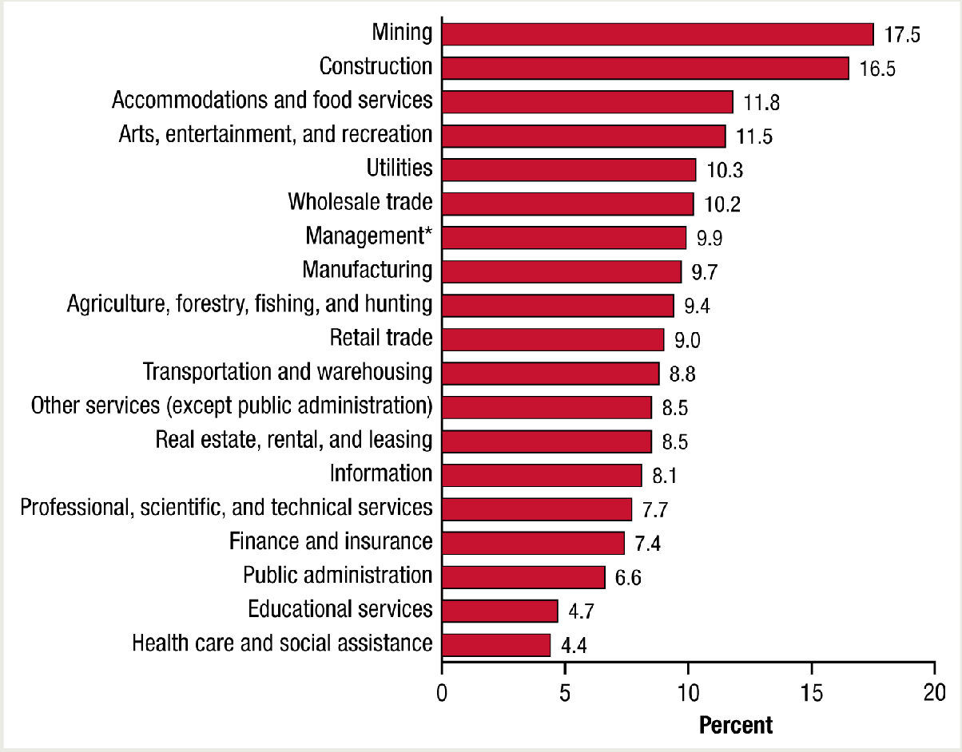

Figure 1. Past month heavy alcohol use among adults aged 18 to 64 employed full time, by industry category: combined 2008 to 2012

* The full title of this category is "Management of companies and enterprises, administration, support, waste management, and remediation services.”
Source: SAMHSA, Center for Behavioral Health Statistics and Quality, National Surveys on Drug Use and Health (NSDUHs) 2008 to 2010 (revised March 2012) and 2011 to 2012.

Workers in the mining (17.5 percent) and construction (16.5 percent) industries had the highest rates of past month heavy alcohol use. For the workers in the construction industry, this finding remained true even when controlling for gender and age differences across industries.7 This indicates that there is something unique about past month heavy alcohol use for the construction industry that would remain even if the construction industry had the same gender and age distribution of any other industry (see Tables A1–A2). However, for the mining industry, this higher rate did not remain when controlling for age or gender differences. This indicates that the high heavy alcohol use rate in the mining industry can be attributed to the demographic composition of the mining industry.

The overall rate of past month illicit drug use among full-time workers aged 18 to 64 was 8.6 percent. Rates of past month illicit drug use ranged from 19.1 percent among workers in the accommodations and food services industry to 4.3 percent among workers in the public administration industry (Figure 2). These findings remained true even when controlling for gender and age differences across industries (see Tables A3–A4).

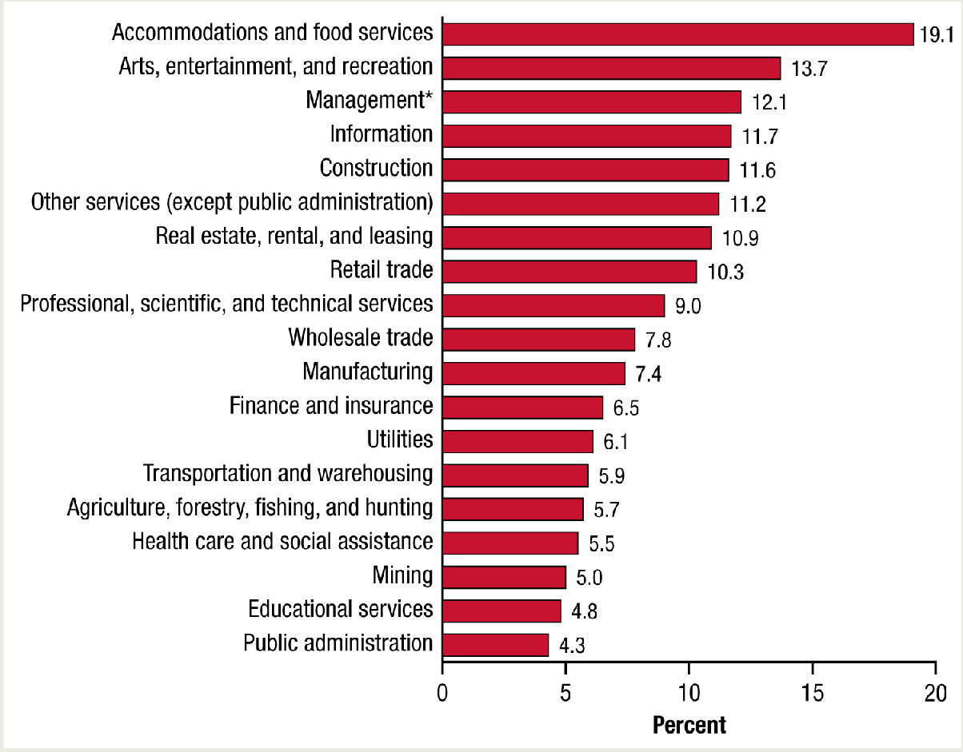

Figure 2. Past month illicit drug use among adults aged 18 to 64 employed full time, by industry category: combined 2008 to 2012

* The full title of this category is "Management of companies and enterprises, administration, support, waste management, and remediation services.”
Source: SAMHSA, Center for Behavioral Health Statistics and Quality, National Surveys on Drug Use and Health (NSDUHs) 2008 to 2010 (revised March 2012) and 2011 to 2012.

The overall rate of past year substance use disorder among full-time workers aged 18 to 64 was 9.5 percent. Rates of past year substance use disorder ranged from 16.9 percent among workers in the accommodations and food services industry to 5.5 percent among workers in the educational services industry (Figure 3). Although the accommodations and food services industry group had the highest rate of past year substance use disorder, this finding did not remain true after controlling for age and gender distributions. This indicates that the high rate can be attributed to the demographic composition of the accommodation and food services industry (see Tables A5–A6).

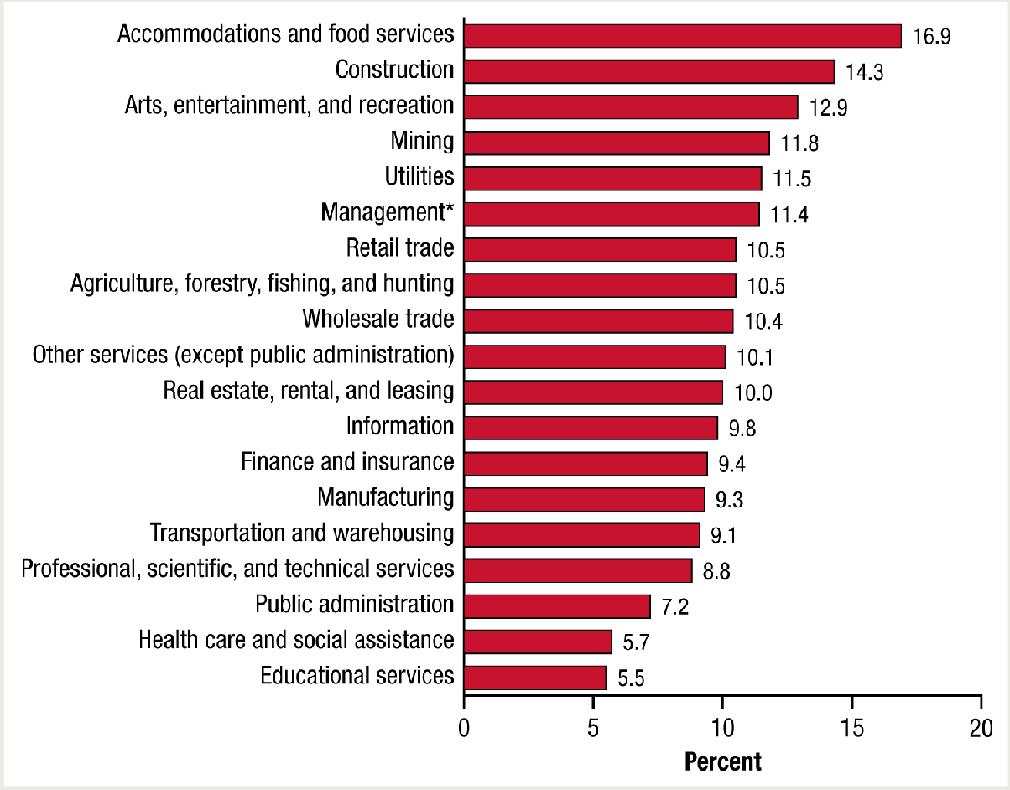
Figure 3. Past year substance use disorder among adults aged 18 to 64
employed full time, by industry category: combined 2008 to 2012
* The full title of this category is "Management of companies and enterprises,
administration, support, waste management, and remediation services.”
Source: SAMHSA, Center for Behavioral Health Statistics and Quality, National Surveys on Drug Use and Health (NSDUHs) 2008 to 2010 (revised March 2012) and 2011 to 2012.

TRENDS

Comparisons between combined 2003 to 2007 data and combined 2008 to 2012 data show some changes in rates of substance use behaviors or disorders by industry category (Figures 4–6). Between the two time periods, rates of past month illicit drug use increased among workers in the accommodations and food services industry (from 16.9 to 19.1 percent) and in the educational services industry (from 3.7 to 4.8 percent), and decreased among workers in the construction services industry (from 13.9 to 11.6 percent). Additionally, decreases were seen in the rates of past year substance use disorder in four industry categories: construction (from 17.3 to 14.3 percent), management (from 13.8 to 11.4 percent), wholesale trade (from 13.4 to 10.4 percent), and manufacturing (from 10.4 to 9.3 percent). The changes within each industry between the two time periods do not account for any changes in the demographic composition (e.g., age distribution) that may have occurred within the industries.

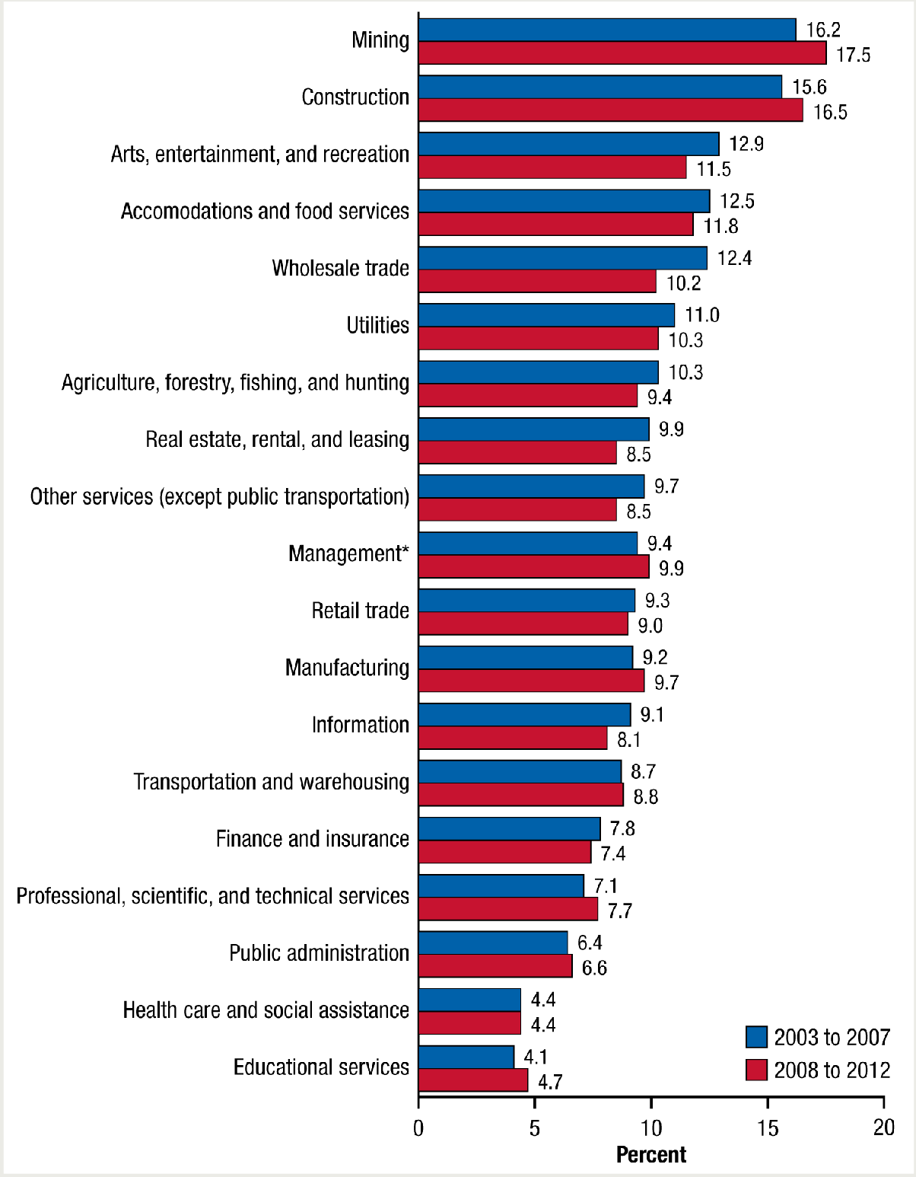
Figure 4. Past month heavy alcohol use among adults aged 18 to 64
employed full time, by industry category: combined 2003 to 2007 and combined 2008 to 2012
* The full title of this category is "Management of companies and enterprises,
administration, support, waste management, and remediation services.”
Source: SAMHSA, Center for Behavioral Health Statistics and Quality, National Surveys on Drug Use and Health (NSDUHs) 2003 to 2005, 2006 to 2010 (revised March 2012)
and 2011 to 2012.

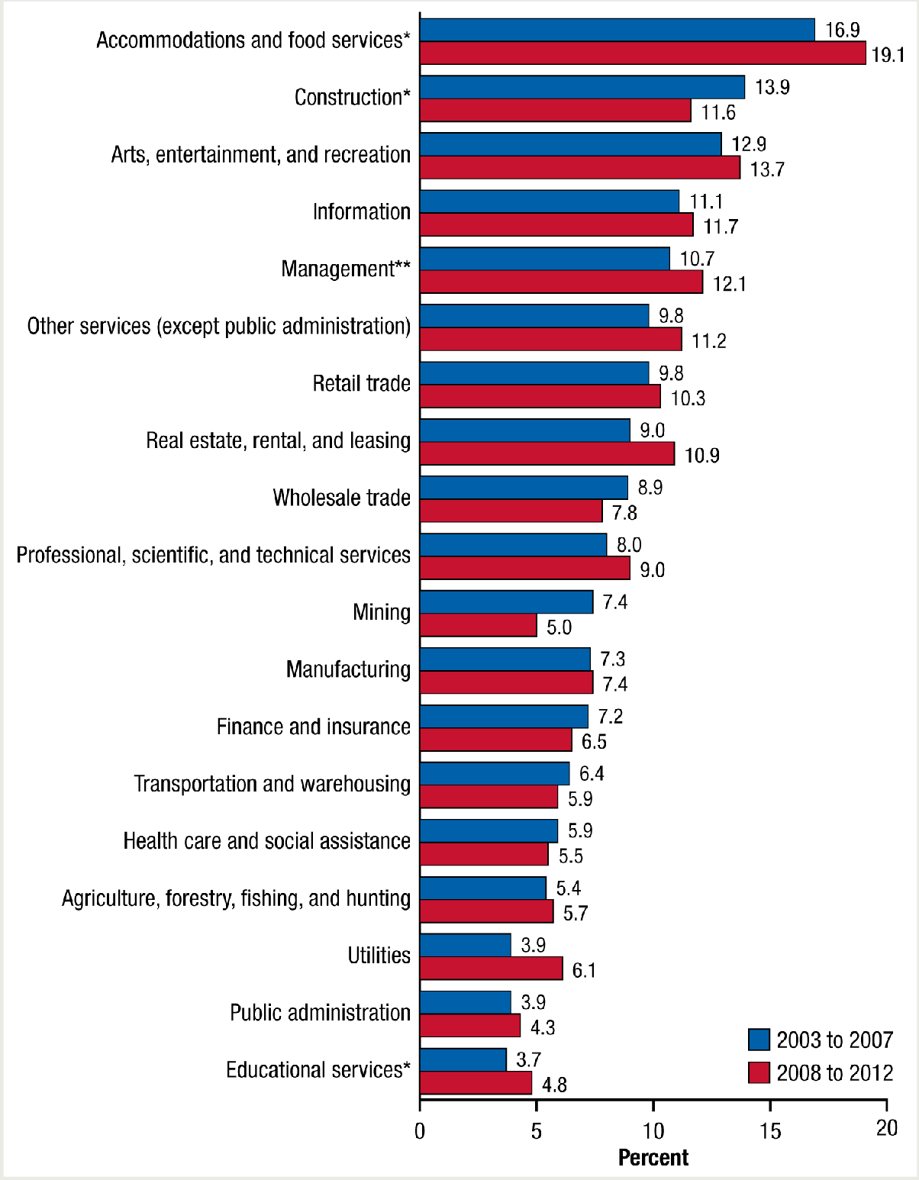
Figure 5. Past month illicit drug use among adults aged 18 to 64 employed
full time, by industry category: combined 2003 to 2007 and combined 2008 to 2012
* Difference between estimates for 2003 to 2007 and for 2008 to 2012 are statistically
significant at .05 level.
** The full title of this category is "Management of companies and enterprises, administration, support, waste management, and remediation services.”
Source: SAMHSA, Center for Behavioral Health Statistics and Quality, National Surveys on Drug Use and Health (NSDUHs) 2003 to 2005, 2006 to 2010 (revised March 2012)
and 2011 to 2012.

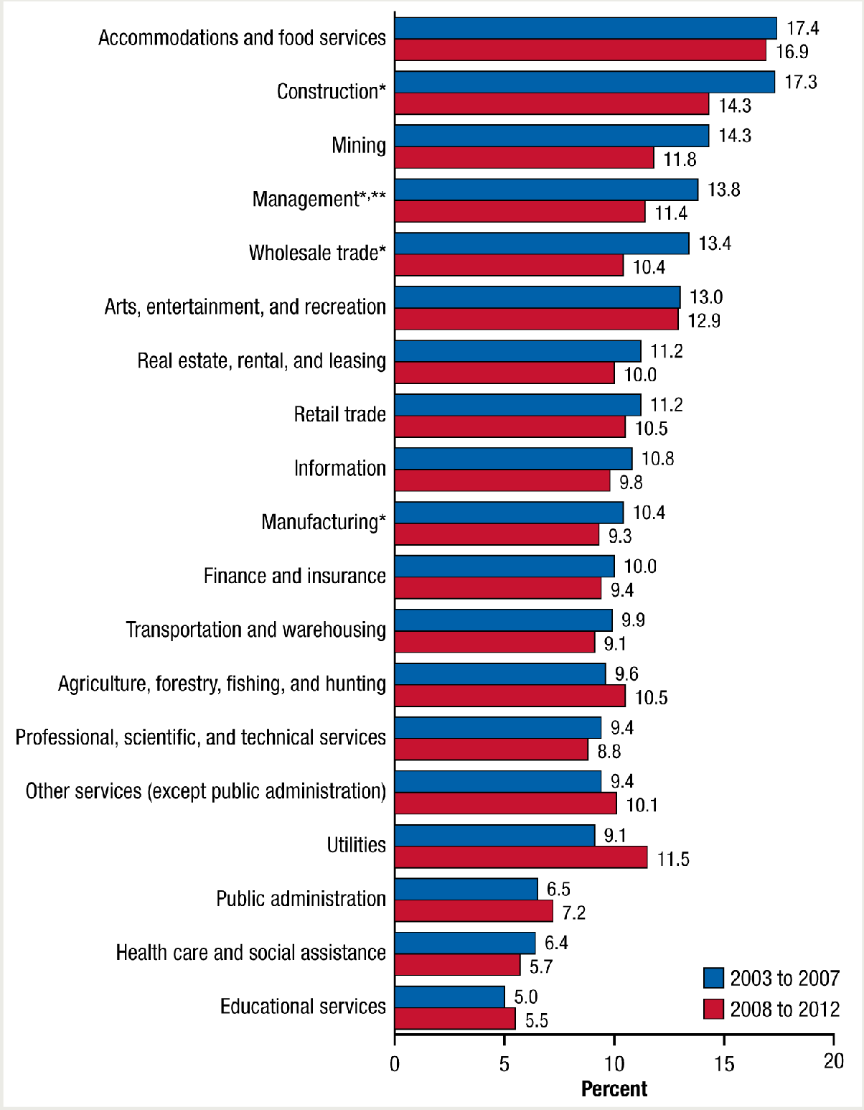
Figure 6. Past year substance use disorder among adults aged 18 to 64
employed full time, by industry category: combined 2003 to 2007 and combined 2008 to 2012
* Difference between estimates for 2003 to 2007 and for 2008 to 2012 are statistically
significant at .05 level.
** The full title of this category is "Management of companies and enterprises, administration, support, waste management, and remediation services.”
Source: SAMHSA, Center for Behavioral Health Statistics and Quality, National Surveys on Drug Use and Health (NSDUHs) 2003 to 2005, 2006 to 2010 (revised March 2012)
and 2011 to 2012.

DISCUSSION

Employee heavy alcohol use, use of illicit drugs, and substance use disorder are associated with negative work behaviors such as absenteeism and frequent job changes.2 This report indicates that the prevalence of substance use and substance use disorders is not consistent across industries. For example, the lowest rates of heavy alcohol use, illicit drug use, and substance use disorder were generally seen in education, health care and social assistance, and public administration. In contrast, higher rates were generally seen in mining, construction, and accommodations and food services industries. There are demographic differences in the age and gender composition across industries, and some of the differences in substance use rates across industries were statistically significant even when controlling for age or gender.
Differences across industries that did not remain significant when controlling for age and gender are still important to identify. Employers in industries that have higher or lower rates of heavy alcohol use, use of illicit drugs, and substance use disorder that can be attributed to the demographic composition of their industry can use this information when developing prevention/education programs.

When heavy alcohol use, use of illicit drugs, and substance use disorder rates are examined over time, it appears that some industries have had a reduction in rates; however, there were increases as well. An extension of this research could examine whether the changes in use rates correspond to either changes in climate in the industries (e.g., attitudes towards substance use, distribution of prevention messages) or shifts in the demographic compositions of the industries across these time periods.

Studies also have indicated that employers vary in their treatment of substance use issues and that workplace-based Employee Assistance Programs can be a valuable resource for obtaining help for substance-using workers.8,9 Given the lifetime health and economic burdens from alcohol use, illicit drug, and substance use disorders, this report illustrates the need to monitor industries individually.

END NOTES

- Office of National Drug Control Policy, Executive Office of the President. (2011). How illicit drug use affects business and the economy. Retrieved from http://www.whitehouse.gov/sites/default/files/ondcp/Fact_Sheets/effects_of_drugs_on_economy_jw_5-24-11_0.pdf
- Larson, S. L., Eyerman, J., Foster, M. S., & Gfroerer, J. C. (2007). Worker substance use and workplace policies and programs (HHS Publication No. SMA 07–4273, Analytic Series A–29). Rockville, MD: Substance Abuse and Mental Health Services Administration, Office of Applied Studies.
- Nonmedical use is defined as the use of prescription-type drugs not prescribed for the respondent by a physician or used only for the experience or feeling they caused. Nonmedical use of any prescription-type pain reliever, sedative, stimulant, or tranquilizer does not include over-the-counter drugs. Nonmedical use of stimulants includes methamphetamine use.
- American Psychiatric Association. (1994). Diagnostic and statistical manual of mental disorders (4th ed.). Washington, DC.
- This test was based on logistic regression models in which gender and age groups were included as main effects predictors along with an industry indicator. Logistic regression is a statistical method used to determine if there is a relationship (that is, an association) between an outcome with two possibilities and a known characteristic, such as gender.
- Center for Behavioral Health Statistics and Quality. (2013). Results from the 2012 National Survey on Drug Use and Health: Summary of national findings
(HHS Publication No. SMA 13–4795, NSDUH Series H–46). Rockville, MD: Substance Abuse and Mental Health Services Administration.
- This was model based in that gender and age groups were included as main effects predictors in logistic regression models along with an industry indicator.
- Delaney, W., Grube, J. W., & Ames, G. M. (1998). Predicting likelihood of seeking help through the Employee Assistance Program among salaried and union hourly employees. Addiction, 93(3), 399–410.
- Reynolds, G. S., & Lehman, W. E. (2003). Levels of substance use and willingness to use the Employee Assistance Program. Journal of Behavioral Health Services & Research, 30(2), 238–248.

SUGGESTED CITATION

D.M. Bush and R.N. Lipari. The CBHSQ Report: Substance Use and Substance Use Disorder, by Industry. (April 16, 2015). Substance Abuse and Mental Health Services Administration, Center for Behavioral Health Statistics and Quality. Rockville, MD.

SUPPORTING TABLES

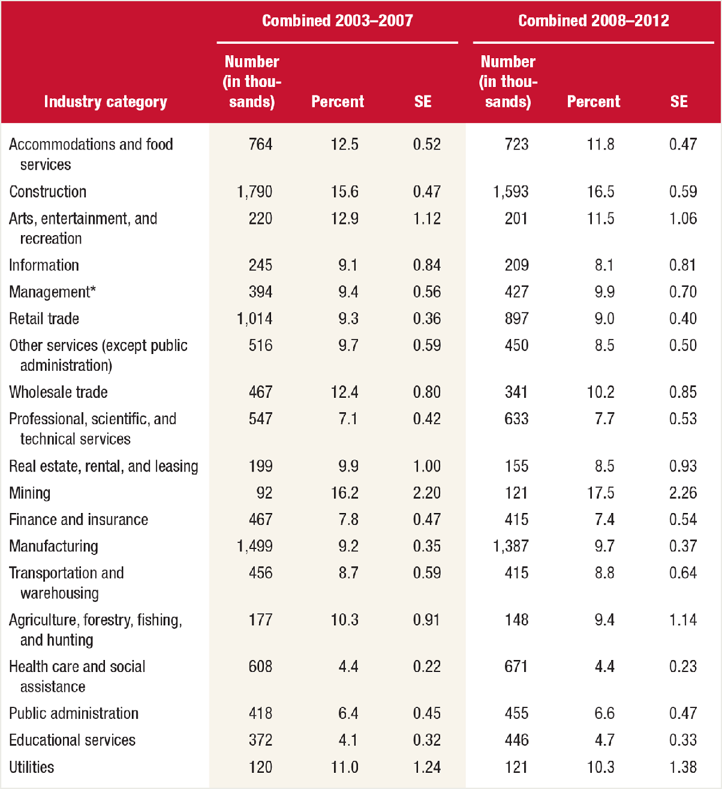

Table S1. Past month heavy alcohol use among full-time workers aged 18 to 64, by industry categories: combined 2003 to 2007 and combined 2008 to 2012 (supports Figures 1 and 4 and text in “Trends” section)

SE = standard error.
* The full title of this category is “Management of companies and enterprises, administration, support, waste management, and remediation services.”
Source: SAMHSA, Center for Behavioral Health Statistics and Quality, National Surveys on Drug Use and Health (NSDUHs), 2003 to 2005, 2006 to 2010 (revised March 2012),
and 2011 to 2012.

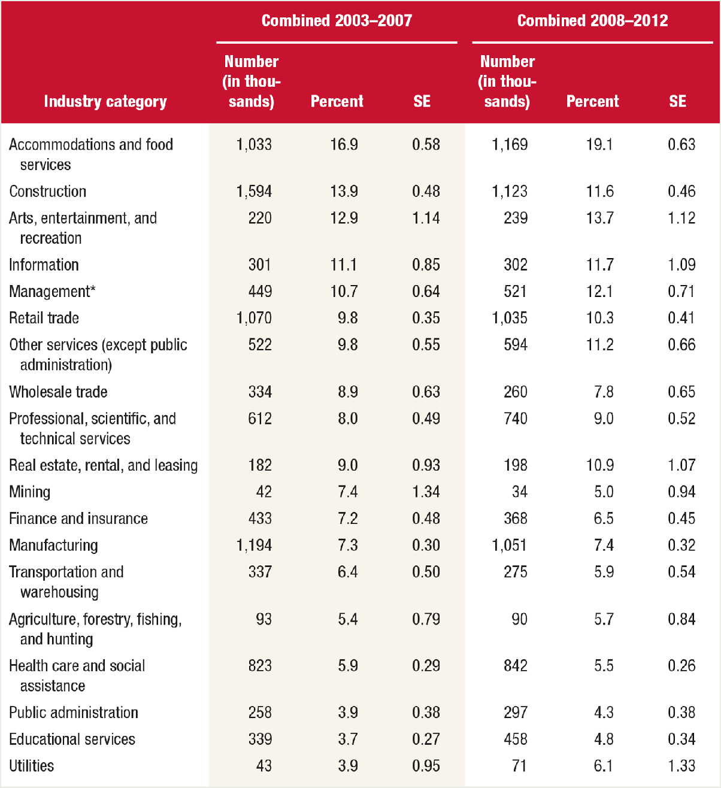
Table S2. Past month illicit drug use among full-time workers aged 18 to 64,
by industry categories: combined 2003 to 2007 and combined 2008 to 2012 (supports Figures 2 and 5 and text in “Trends” section)
SE = standard error.
* The full title of this category is “Management of companies and enterprises, administration, support, waste management, and remediation services.”
Source: SAMHSA, Center for Behavioral Health Statistics and Quality, National Surveys on Drug Use and Health (NSDUHs), 2003 to 2005, 2006 to 2010 (revised March 2012),
and 2011 to 2012.

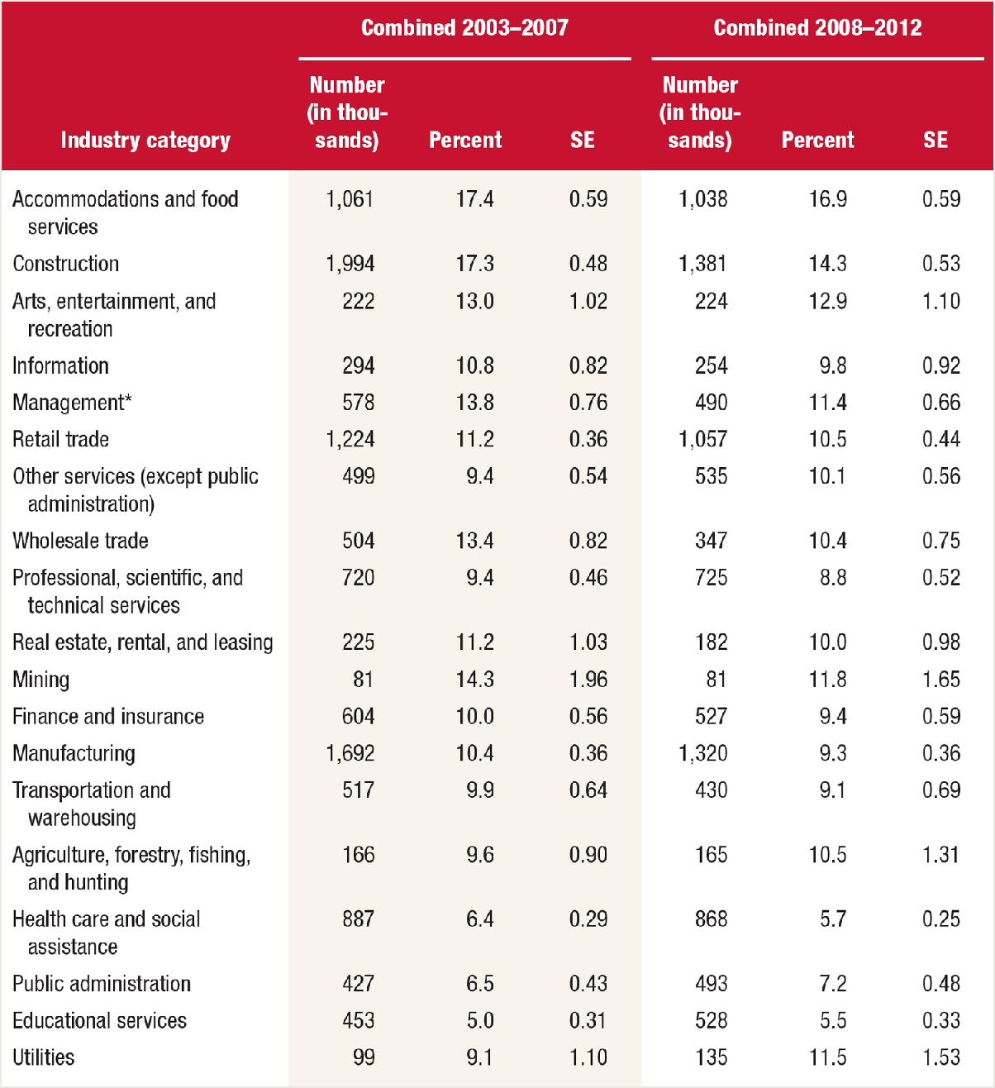
Table S3. Past year substance use disorder among full-time workers aged 18-
64, by industry categories: combined 2003 to 2007 and combined 2008 to 2012 (supports Figures 3 and 6 and text in “Trends” section
SE = standard error.
* The full title of this category is “Management of companies and enterprises, administration, support, waste management, and remediation services.”
Source: SAMHSA, Center for Behavioral Health Statistics and Quality, National Surveys on Drug Use and Health (NSDUHs), 2003 to 2005, 2006 to 2010 (revised March 2012),
and 2011 to 2012.

ADDITIONAL TABLES

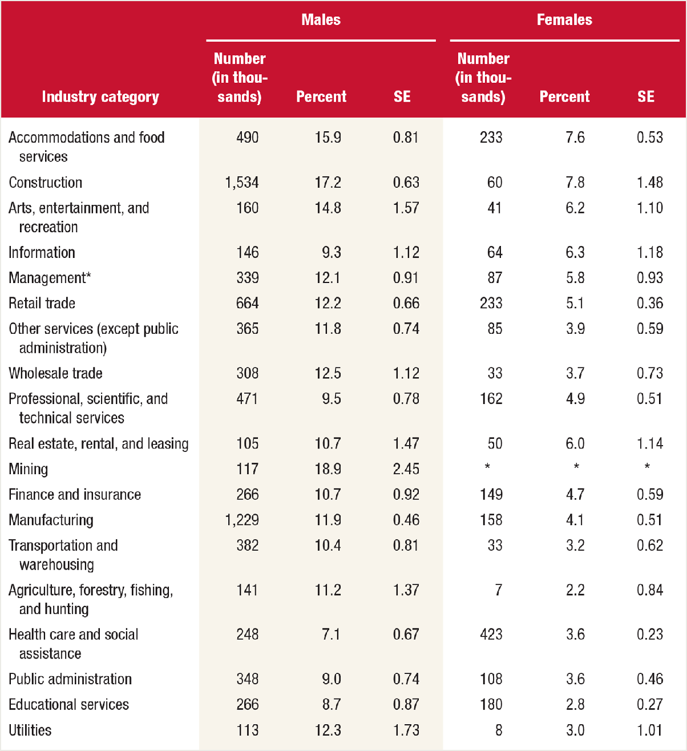

Table A1. Past month heavy alcohol use among full-time workers aged 18 to 64, by industry categories and gender: combined 2008 to 2012

SE = standard error.
*Low precision; no estimate reported.
** The full title of this category is “Management of companies and enterprises, administration, support, waste management, and remediation services.”
Source: SAMHSA, Center for Behavioral Health Statistics and Quality, National Surveys on Drug Use and Health (NSDUHs) 2008 to 2010 (revised March 2012) and 2011 to 2012.

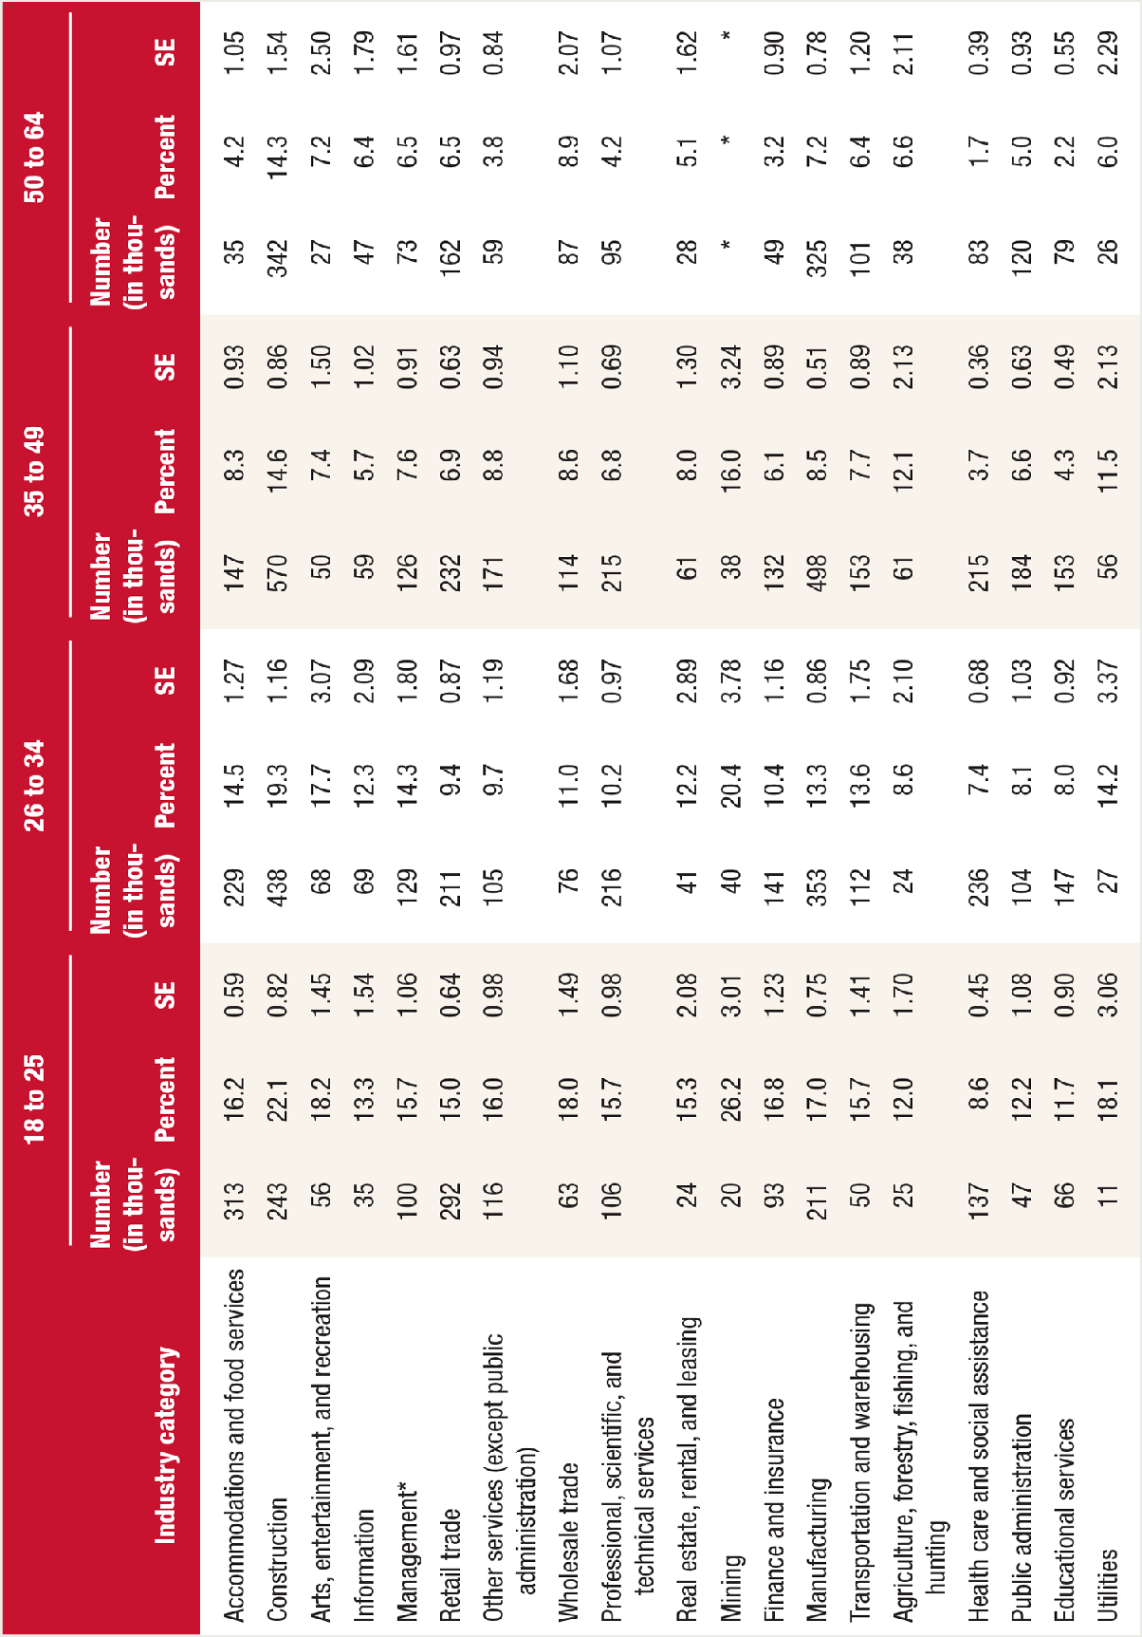
Table A2. Past month heavy alcohol use among full-time workers aged 18 to
64, by industry categories and age group: combined 2008 to 2012
SE = standard error.
*Low precision; no estimate reported.
** The full title of this category is “Management of companies and enterprises, administration, support, waste management, and remediation services.”
Source: SAMHSA, Center for Behavioral Health Statistics and Quality, National Surveys on Drug Use and Health (NSDUHs) 2008 to 2010 (revised March 2012) and 2011 to
2012.

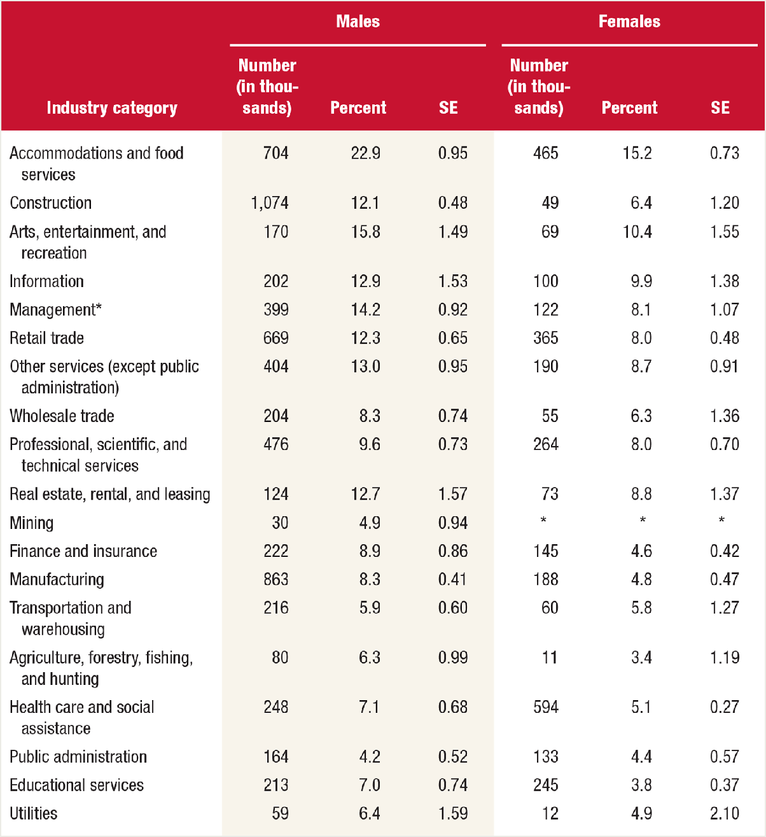
Table A3. Past month illicit drug use among full-time workers aged 18 to 64,
by industry categories and gender: combined 2008 to 2012
SE = standard error.
*Low precision; no estimate reported.
** The full title of this category is “Management of companies and enterprises, administration, support, waste management, and remediation services.”
Source: SAMHSA, Center for Behavioral Health Statistics and Quality, National Surveys on Drug Use and Health (NSDUHs) 2008 to 2010 (revised March 2012) and 2011 to
2012.

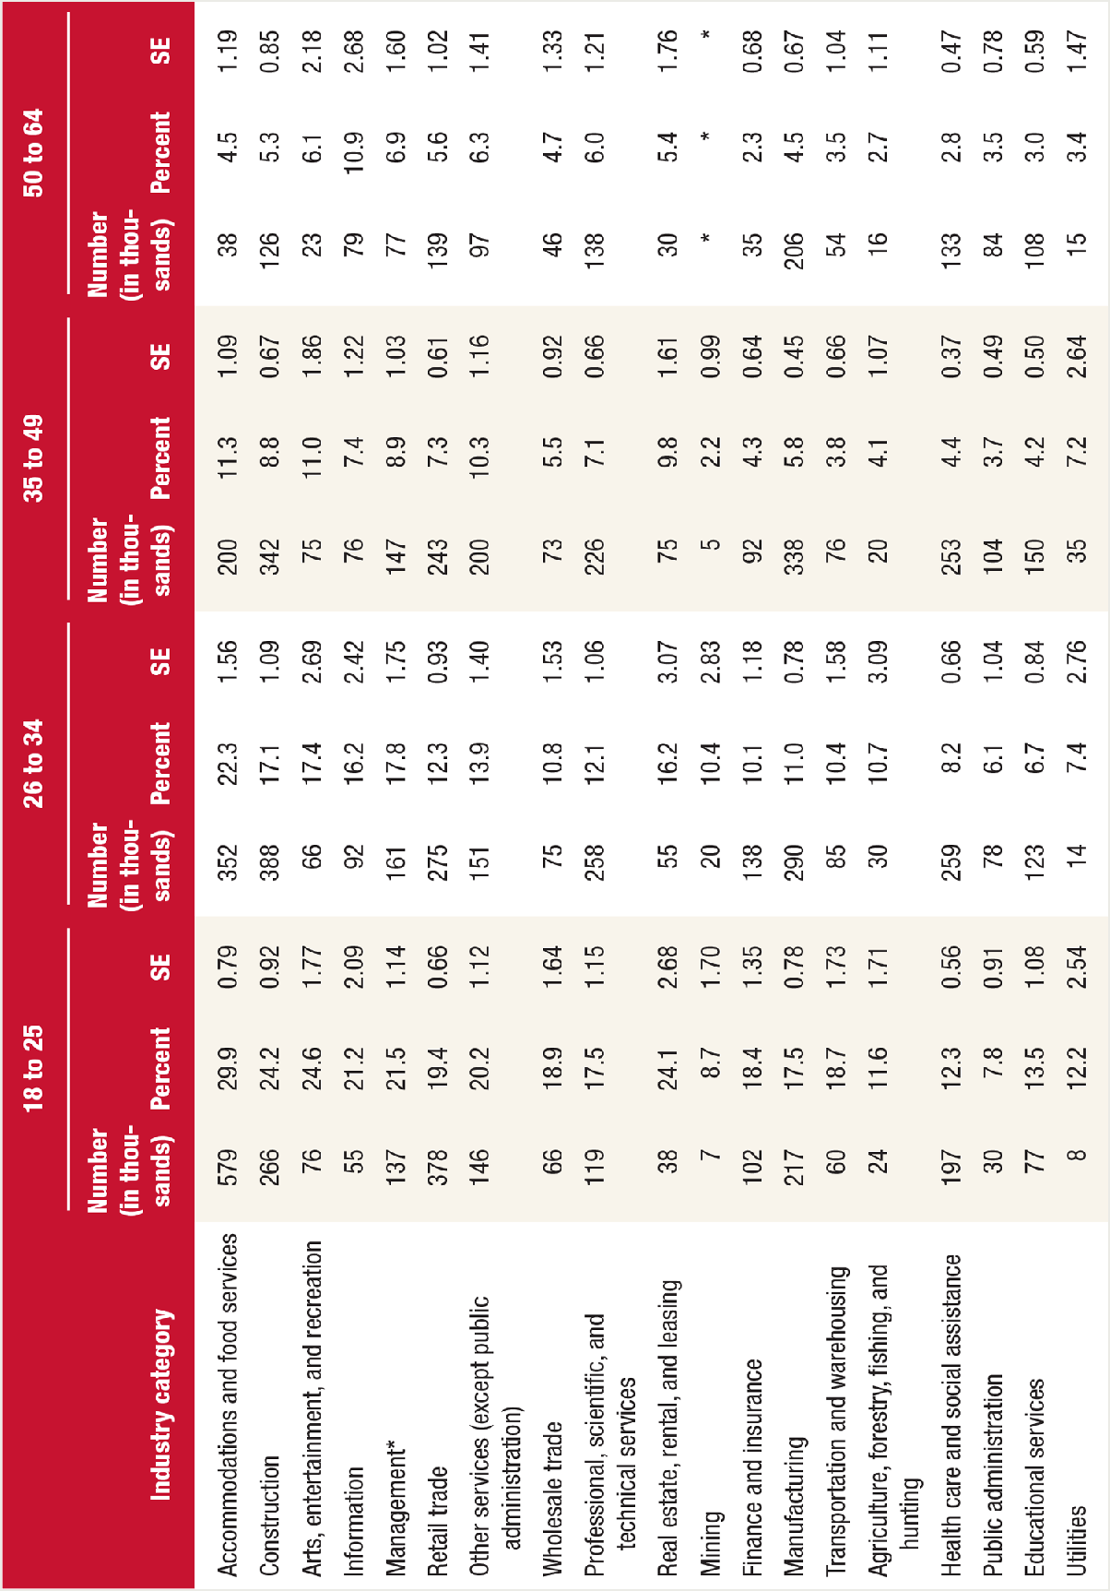
Table A4. Past month illicit drug use among full-time workers aged 18 to 64,
by industry categories and age group: combined 2008 to 2012
SE = standard error.
*Low precision; no estimate reported.
** The full title of this category is “Management of companies and enterprises, administration, support, waste management, and remediation services.”
Source: SAMHSA, Center for Behavioral Health Statistics and Quality, National Surveys on Drug Use and Health (NSDUHs) 2008 to 2010 (revised March 2012) and 2011 to
2012.

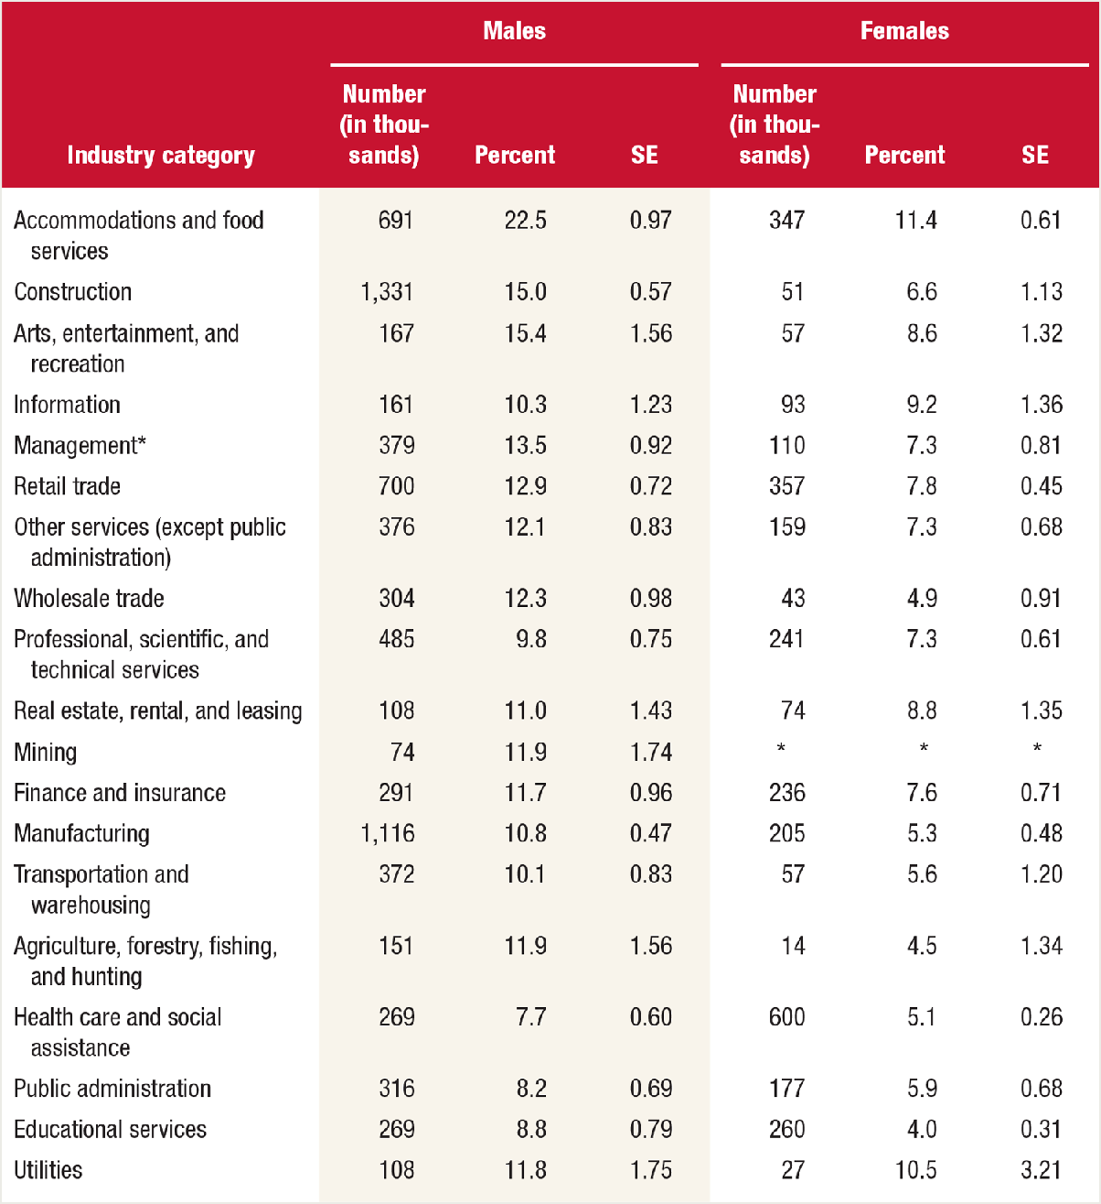
Table A5. Past year substance use disorder among full-time workers aged 18
to 64, by industry categories and gender: combined 2008 to 2012
SE = standard error.
*Low precision; no estimate reported.
** The full title of this category is “Management of companies and enterprises, administration, support, waste management, and remediation services.”
Source: SAMHSA, Center for Behavioral Health Statistics and Quality, National Surveys on Drug Use and Health (NSDUHs) 2008 to 2010 (revised March 2012) and 2011 to
2012.

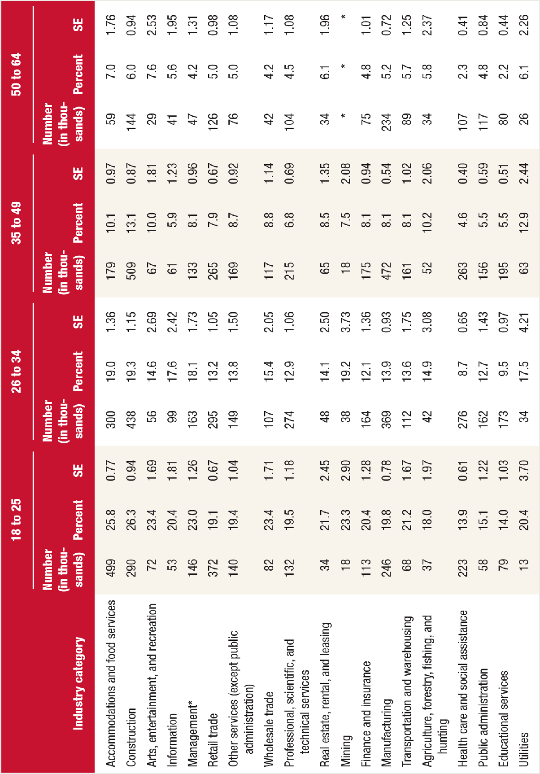
Table A6. Past year substance use disorder among full-time workers aged 18
to 64, by industry categories and age group: combined 2008 to 2012
SE = standard error.
*Low precision; no estimate reported.
** The full title of this category is “Management of companies and enterprises, administration, support, waste management, and remediation services.”
Source: SAMHSA, Center for Behavioral Health Statistics and Quality, National Surveys on Drug Use and Health (NSDUHs) 2008 to 2010 (revised March 2012) and 2011 to
2012.

SUMMARY

Background: Substance use negatively affects U.S. industry through lost productivity, workplace accidents and injuries, employee absenteeism, low morale, and increased illness. Research shows that the rate of substance use varies by occupation and industry. Method: Combined 2003- 2007 and 2008-2012 National Survey on Drug Use and Health (NSDUH) estimates for past month heavy alcohol use, past month illicit drug use and past year substance use disorder (SUD) for full-time employees aged 18-64 in 19 industry categories were analyzed. Results: Combined data from 2008-2012 indicate an annual average of 8.7% of full-time workers aged 18 to 64 used alcohol heavily, 8.6% used illicit drugs, and 9.5% had SUD. The highest rates of heavy alcohol use were found in the mining (17.5%) and construction industries (16.5%). The highest rates
of illicit drug use were found in the accommodations and food services industry (19.1%). Workers in the accommodations and food services industry (16.9%) had the highest SUD rates. Between the two time periods, rates of illicit drug use increased in the accommodations and food services industry (from 16.9 to 19.1%) and in the educational services industry (from 3.7 to 4.8%), and decreased among workers in the construction services industry (from 13.9 to11.6%). Decreases were seen in the past year SUD rates in construction (from 17.3 to 14.3%), management (from 13.8 to 11.4%), wholesale trade (from 13.4 to 10.4%), and manufacturing (from 10.4 to 9.3%). Conclusion: The prevalence of substance use and SUD is not consistent across industries. The lowest rates of heavy alcohol use, illicit drug use, and SUD were generally seen in education, health care and social assistance, and public administration. Higher rates were generally seen in mining, construction, and accommodations and food services industries. When heavy alcohol use, use of illicit drugs, and SUD are examined over time, it appears that some industries have had a reduction in rates; however, there were increases as well.

Keywords: full time workers aged 18-64, worker drug use, industry, illicit drug use, heavy alcohol use, substance use disorder, National Survey on Drug Use and Health, NSDUH

AUTHOR INFORMATION

cbhsqrequest@samhsa.hhs.gov

KEYWORDS

Occupation, Short Report, Population Data, 2012, Employers, Public Health Professionals, Alcohol Abuse, Substance Abuse, Workers and Workplace, Drug Use Trends, Workplace Trends, Alcohol, Illegal Drugs, Multi-Year Trend, All US States Only

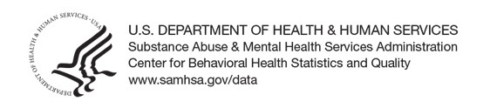

The Substance Abuse and Mental Health Services Administration (SAMHSA) is the agency within the U.S. Department of Health and Human Services that leads public health efforts to advance the behavioral health of the nation. SAMHSA's mission is to reduce the impact of substance abuse and mental illness on America's communities.

The National Survey on Drug Use and Health (NSDUH) is an annual survey sponsored by The Substance Abuse and Mental Health Services Administration (SAMHSA). The data used in this report are based on information obtained from adolescents aged 12 to 17 (23,500 in 2001 and 22,500 in 2012). The Survey collects data by administering questionnaires to a representative sample of the population through face-to-face interviews at their place of residence.

The NSDUH Report is prepared by The Center for Behavioral Health Statistics and Quality (CBHSQ), SAMHSA, and by RTI International in Research Triangle Park, North Carolina. (RTI International is a trade name of Research Triangle Institute.)

Information on the most recent NSDUH is available in the following publication:

Center for Behavior Health Statistics and Quality. (2013). Results from the 2012 National Survey on Drug Use and Health: Summary of national findings (HHS Publication No. SMA 13-4795, NSDUH Series H-46). Rockville, MD : Substance Abuse and Mental Health Services Administration.

Also available online: http://www.samhsa.gov/data/population-data-nsduh.

